

**RIGA TECHNICAL UNIVERSITY  
Faculty of Computer Science and Information Technology**

**Institute of Applied Computer Systems**

**“Data Structures Assignmnets”**

TASK OF INDIVIDUAL WORK  
**"DIP203 - Data Structures”**

**Lect, Padmaraj Nidagundi**

**Accomplished:** Said Naghiyev **Student Card No:** 201ADB100

2020./2021.

**Index**

1. Develop four algorithms to improve maths grade in school
2. Write an algorithm to find all roots of a quadratic equation ax2+bx+c=0. (write a program in c or c++/java)
3. Write an algorithm convert temperature from degree celsius to fahrenheit
4. Write an algorithm to find the largest among three different numbers entered by the user.(write a program in c or c++/java)
5. Write an algorithm "Facebook friend suggest" feature
6. Write an algorithm "youtube video suggest" feature
7. Write an algorithm "biometric face recognition " feature
8. Write an algorithm for making ice cream ( use your own ingredients )
9. Answer the following questions
10. What is an algorithm? What is the need for an algorithm?
11. What is the Complexity of Algorithm? Explain 1) Time complexity 2) Space complexity?
12. What are the Asymptotic Notations?
13. What are the algorithm characteristics?
14. Explain Big-O complexities and its learning benefits for programming
15. **Develop four algorithms to improve maths grade in school**

Step 0:Improve maths grade in school

Step 1:Find the Problems

Step 2:Find solution for the Problems

Step 3:Attend more classes + ask Problems to teacher + get help from parents + go to library

Step 4:Do more exams and test

Step 5:Repeat old subjects

Step 6:Find other problems + try to solve them

Step 7:Write exams

1. **Write an algorithm to find all roots of a quadratic equation ax2+bx+c=0. (write a program in c or c++/java)**

//#include<bits/stdc++.h>

#include<iostream>

#include<cmath>

using namespace std;

float a,b,c,x1,x2,realNum,imageNum,dis;

void printResult(int r){

switch(r){

case(0):

cout<<"Roots are complex!"<<endl;

cout<<"x1 = "<<realNum<<"+"<<imageNum<<"i"<<endl;

cout<<"x2 = "<<realNum<<"-"<<imageNum<<"i"<<endl;

break;

case(1):

cout<<"x = "<<x1<<endl;

cout<<endl;

cout<<a<<"*"<<x1<<"^2";

if(b>=0){

cout<<"+";

}

cout<<b<<"*"<<x1;

if(c>=0){

cout<<"+";

}

cout<<c<<" = 0"<<endl;

break;

case(2):

cout<<"x1 = "<<x1<<endl;

cout<<"x2 = "<<x2<<endl;

cout<<endl;

cout<<a<<"*"<<x1<<"^2";

if(b>=0){

cout<<"+";

}

cout<<b<<"*"<<x1;

if(c>=0){

cout<<"+";

}

cout<<c<<" = 0"<<endl;

cout<<endl;

cout<<a<<"*"<<x2<<"^2";

if(b>=0){

cout<<"+";

}

cout<<b<<"*"<<x2;

if(c>=0){

cout<<"+";

}

cout<<c<<" = 0"<<endl;

break;

}

return;

}

int main(){

cout<<"ax^2 + bx + c = 0"<<endl;

cout<<"a = ";

cin>>a;

cout<<"b = ";

cin>>b;

cout<<"c = ";

cin>>c;

dis = b*b - 4*a*c;//find Discriminant

if(dis>0){ //Discriminant has 2 roots

x1 = (-1*b + sqrt(dis))/(2*a);

x2 = (-1*b - sqrt(dis))/(2*a);

printResult(2);

}

else if(dis==0){ //Discriminant has 1 root

x1 = (-1*b + sqrt(dis))/(2*a);

printResult(1);

}

else{ //Discriminant has no real roots

realNum = (-1*b)/(2*a);

imageNum = sqrt(-1 * dis) / (2*a);

printResult(0);

}

return 0;

}

//Picture of code

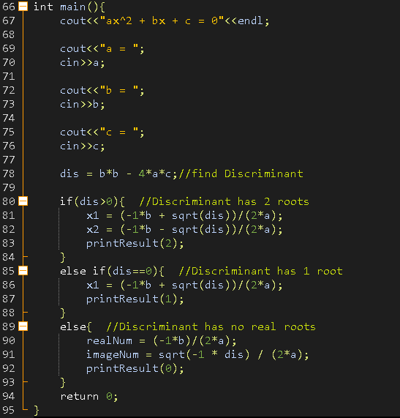

Result

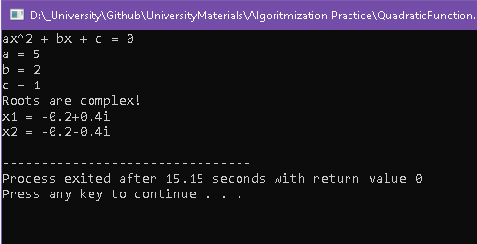

1. **Write an algorithm convert temperature from degree celsius to fahrenheit**

#include<iostream>

using namespace std;

int main(){

float c;

cout<<"input C"<<endl;

cin>>c;

cout<<"fahrenheit:"<<endl;

cout<<(c*9/5)+32<<" F"<<endl;

return 0;

}

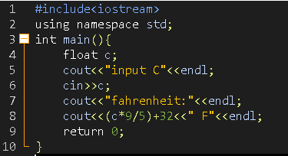

Result:

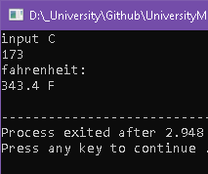

1. **Write an algorithm to find the largest among three different numbers entered by the user.(write a program in c or c++/java)**

#include<iostream>

using namespace std;

int main(){

float a,b,c;

cout<<"enter 3 number"<<endl;

cin>>a>>b>>c;

cout<<max(a,max(b,c))<<endl;

return 0;

}

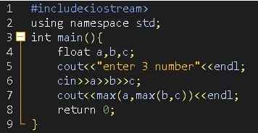

Result:

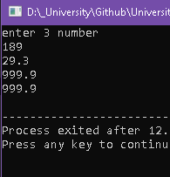

1. **Write an algorithm "Facebook friend suggest" feature**

Step 0: "Facebook friend suggest" feature

Step 1: Find friends of my friends

Step 2: Find potential Friend coomon friend

Step 3: if potential Friend has more than 1 common friend Suggest potential friend

Step 4: Find location of user

Step 5: Find nearest users

Step 6: Find nearest users commond friend

Step 7: if portential friend is more than 0 then suggest nearest friends

Step 8: find workplace or school

Step 9: Find Workers or student of this workplace and suggest them

Step 10: Find who watched same movies or read books

Step 11: suggest

1. **Write an algorithm "youtube video suggest" feature**

Step 0: "youtube video suggest" feature

Step 1: Find Click-through rate

Step 2: Find most viewed videos

Step 3: Find Trend video on your country

Step 4: Find Subscribed channel Videos

Step 5: get watched videos and find related videos

Step 6: Show videos on frontpage

Step 7: Step 1;

1. **Write an algorithm "biometric face recognition " feature**

Step 0: Write an algorithm "biometric face recognition " feature

Step 1:

1. **Write an algorithm for making ice cream ( use your own ingredients )**

## Step 1: Find or get Ingredients

## 1. whole milk 2. sugar 3. pure vanilla extract 4. cream

## Step 2: Mix milk and sugar

## Step 3: Add cream and vanilla

## Step 4: Mix ice cream for 30 minute

## Step 5: put in pot

## Step 6: freeze for 2 hours

## Step 7: Enjoy

1. **A) What is an algorithm? What is the need for an algorithm?**

An **algorithm** is a list of rules to follow in order to solve a problem.

In daily life we are solving many problems by algorithms

Example:

Problem is go to work

First step is get up then fix your place

Wash your face

Second make breakfast and eat it

Wear clothes and go to work

Algorithms can be used in computer for solving problems too.

To find root of quadratic equation we need make some steps to find solution.

1. **What is the Complexity of Algorithm? Explain 1) Time complexity 2) Space complexity?**